8. JOINTS
JOINT: It’s connection between two or more members.
Types of Joints
Movable Joints |  | Im-Movable Joints
Translational Joints | Rotational Joints | Permanent Joints | Temporary Joints
Prismatic Joints | Pin Joints | Welded or Riveted Joints | Bolted Joints
RIVET: It’s the one-piece fastener used to connect two or more machine members.
PARTS OF RIVET |  |  |  | 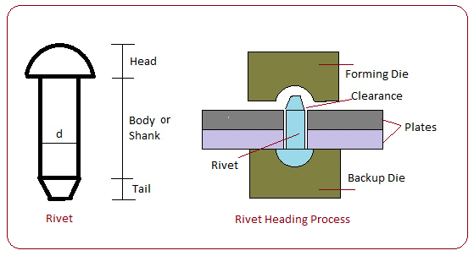  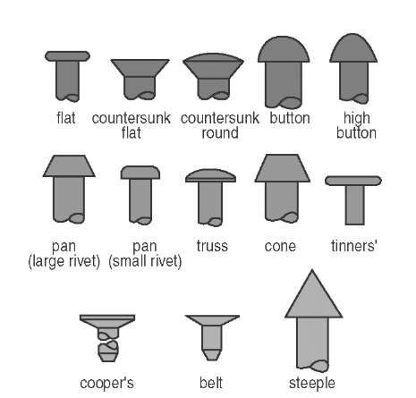
HEAD | SHANK |  | TAIL
Made using upsetting (Automatic Header machine) | Shank is always concentric with head and tail axis. |  | It converts shape after ramming is called point.
Used at less vibrations place.
TYPES OF RIVETS:
Based on Temperature:  - Cold Riveting: More force  - Hot Riveting: Less force |  | Based on Hammering:  - Hand Riveting:  - Machine Riveting:
Based on Head:
- Round head rivet: Used in large structure work where strength is needed. Strong joint, most widely used rivet. It’s protrusion joint.
- Universal/Pan head rivet: Used for girders and heavy constructional engineering. Strong joint. It’s protrusion joint.
- Cone/Pan Head Rivet: Used for girders and heavy constructional engineering. Strong joint. It’s protrusion joint.
- Countersunk head rivet: Ship hulls below the water line. Protrusion is avoided. Less Strong.
- Flat/Tinman Smithy Head Rivet: Used in most general sheet material fabrication.
Material Used: Ductile Material. Eg. Steel, Aluminium, Copper.
Important Point:  - Diameter of shank (d): Dimensions of the rivet are specified by shank diameter.  - Thickness of plates to be joint (t):  - Unwin’s equations: Empirical Relation $d=6\sqrt{t}, where t>8 mm$. | Process of Riveting:  - Making holes using punching and drilling processes.  - Hammering using hammer and die arrangements.

LAP JOINT | BUTT JOINT
It’s joint formed by placing one plate over the another. | It’s joint obtained by joining the plates by bringing them together by their edges. We will use additional plate called Strap/ Cover Plate.
- Single Riveted Lap joint: 1 Raw  - Double Riveted Lap joint: 2 Raw  - Triple Riveted Lap joint: 3 Raw  - Chain Riveted Lap joint: Rivet in a raw is exactly opposite to the rivet in the adjacent raw. (> 1 Rivet)  - Zig-Zag Riveted Lap joint: Rivet in a raw is at the centre location of the rivets in the adjacent raw.  - Diamond/ Convergent Zig-Zag Riveted Lap joint: Most economic joint. | - Single Strap Single Riveted Butt Joint:  - Double Strap Single Riveted Butt Joint:  - Double Strap Double Riveted Butt Joint:  - Double Strap Triple/Chain Riveted Butt Joint:  - Double Strap Zig-Zag Riveted Butt Joint:  - Double Strap Diamond/ Convergent Zig-Zag Riveted Butt joint:

TERMINOLOGY USED IN RIVETING:  - Centre of Rivet: It’s centroid of cross-section of rivet.  - Riveting System: It’s the collection of all rivets.  - Centre of Gravity of Riveting system: It’s the centroid of cross-section obtained by joining centre of all rivets.  - Row: It’s the line of rivets perpendicular to the direction of loading. Eg. One rows – Single Riveted. Two rows – Double Riveted. Three rows – Triple Riveted.  - Pitch (p): It’s the centre distance between two adjacent rivets of the same row.  - Back Pitch (p_{b}): It’s the centre line distance two adjacent row.  - Diagonal Pitch (p_{d}): It’s the centre distance between two rivets of adjacent row.  - Margin (m): It’s shortest distance between centre of rivet of edge of plate.  ASSUMPTIONS:  - When Width of the plate is not specified, consider it as infinite width plate.  - Load is passing through CG of riveting system.  - Consider the riveting arrangement only in the pitch region.  - The load given is the load per pitch length.  NUMBER OF RIVETS PER PITCH (n): It represents the number of rivets per pitch length throughout the parent plate.  Single Riveted: 1 raw => n = 1 Double Riveted: 2 raw => n = 2 Triple Riveted: 3 raw => n = 3 For Chain/ Zig-Zag Lap/Butt Joint  TENSILE FAILURE OF PLATE IN LAP/ BUTT JOINT:  Here, Rivet is stronger than Plate. So, tearing of plates happened.  Length of Tearing = $p-2r$ $$A_{t}=\left(p-2r\right)t$$ $$F_{t}=σ_{yt}A_{t}=σ_{yt}\left(p-2r\right)t$$ $A_{t}$= area of tearing, $F=F_{t}=$ load acting on the plate in the pitch length = Tearing strength, $σ=σ_{yt}$= Failure Stress of plate = Yield Stress,  SHEAR FAILURE OF RIVET IN LAP/ BUTT JOINT:  Here, Plate is stronger than Rivet. So, Shearing of Rivet happened. (For Cold Rivet)  $$A_{s}= n\frac{π}{4}d^{2}$$ $$F_{s}=τ_{yt}A_{s}=τ_{yt}(nk)\frac{π}{4}d^{2}$$ d = Diameter of rivet, $A_{s}$= Area of Shearing rivet, $F=F_{s}=$ load acting over pitch length = Shearing strength, $τ=τ_{yt}$= Shear Failure of rivet = Yield Shear Stress, $k$ = No. of Strap Plates in Butt Riveted Joint. | 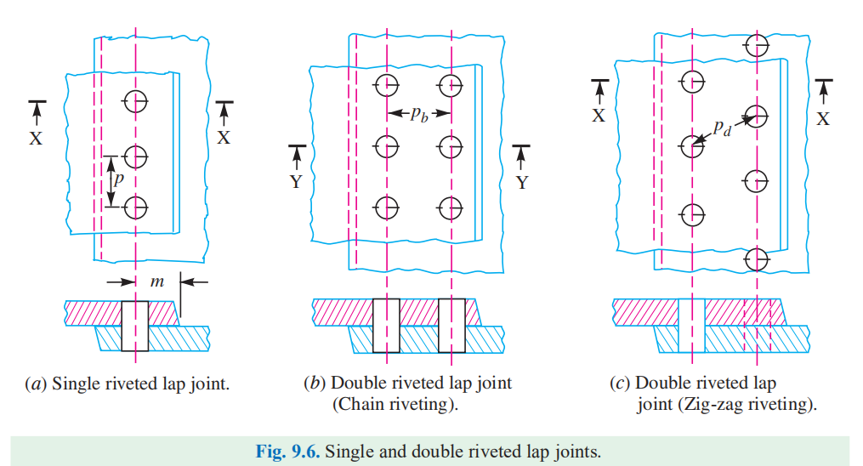  
CRUSHING FAILURE OF PLATE IN LAP/ BUTT JOINT:
Both rivet and plates are relatively stronger. So, Compressive failure of plate is happened.
$$A_{p}= ndt$$  $$F_{cr}=σ_{cr}A_{p}=σ_{cr}ndt$$ | $σ_{cr}$= Crushing Stress of plate,  $F_{cr}$ = Crushing Strength of riveting system,
EFFICIENCY OF THE RIVETED JOINT:
$$F_{WOR}=σ_{yt}pt, And Efficiency \left(η\right)=\frac{F_{WR}}{F_{WOR}}$$  Efficiency of joint $η=\min\left\{η_{t},η_{s},η_{c}\right\}$  $$η= \frac{\min\left\{F_{t},F_{s},F_{cr}\right\}}{F_{WOR}}$$ | Tearing Efficiency $\left(η_{t}\right)=\frac{σ_{yt}\left(p-2r\right)t}{σ_{yt}pt}=1-\frac{d}{p}$  Shearing Efficiency $\left(η_{s}\right)=\frac{τ_{ys}(nk)\frac{π}{4}d^{2}}{σ_{yt}pt}$  Crushing Efficiency $\left(η_{c}\right)=\frac{σ_{cr}(n)dt}{σ_{yt}pt}$

Plate:  - $F_{t}=σ_{yt}A_{t}=σ_{yt}\left(p-d\right)t$  - $F_{cr}=σ_{cr}A_{p}=σ_{cr}ndt$  Rivet:  - $F_{s}=τ_{yt}A_{s}=τ_{yt}(nk)\frac{π}{4}d^{2}$  $$F_{WR}=\min\left\{F_{t},F_{s},F_{cr}\right\}$$ | $$η= \frac{\min\left\{F_{t},F_{s},F_{cr}\right\}}{F_{WOR}}$$  Find diameter method 1: $d=6\sqrt{t}, where t>8 mm$  Find diameter method 2: $t, σ_{cr}, τ_{yt}$ are known. $F_{s}=F_{cr}$. | Finding Pitch:  $$F_{t}=F_{s}$$  To avoid Shearing of Plate near margin. And Tearing of plate near margin.  $$m=1.5d$$
TENSILE FAILURE OF FINITE LENGTH PLATE:
Single Riveted | Double Riveted
$$A_{min}=\left(w-xd\right)t$$  $$F_{t}=σ_{yt}A_{min}=σ_{yt}\left(w-xd\right)t$$ | - Tearing of first row: equation remains same as single riveted joint.  - Tearing of Second Row: 1) 1st row should fail by either shear or crushing. 2) after that shearing of 2nd row.
SHEAR FAILURE OF RIVET IN FINITE LENGTH PLATE:
$$A_{s}= nx\frac{π}{4}d^{2}$$  $$F_{s}=τ_{yt}A_{s}=τ_{yt}(nxk)\frac{π}{4}d^{2}$$ | d = Diameter of rivet,  x = Number of rivets in a single raw,  $A_{s}$= Area of Shearing rivet,  $F=F_{s}=$ load acting on plate = Shearing strength,  $τ=τ_{yt}$= Shear Failure of rivet = Yield Shear Stress,  $k$ = No. of Strap Plates in Butt Riveted Joint.
CRUSHING FAILURE OF FINITE LENGTH PLATE IN LAP/ BUTT JOINT:
Both rivet and plates are relatively stronger. So, Compressive failure of plate is happened.
$$A_{p}= xndt$$  $$F_{cr}=σ_{cr}A_{p}=σ_{cr}xndt$$ | $σ_{cr}$= Crushing Stress of plate,  $F_{cr}$ = Crushing Strength of riveting system,  x = Number of rivets in a single raw,
THREADED JOINTS:
If the joint is made by using threaded fasteners then the obtained joint is said to be threaded/ separable/ detachable/ temporary joint.  Bolt Nut Screw Stud Bolt  Types of Thread: - Right hand Thread - Left Hand Thread 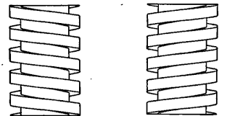 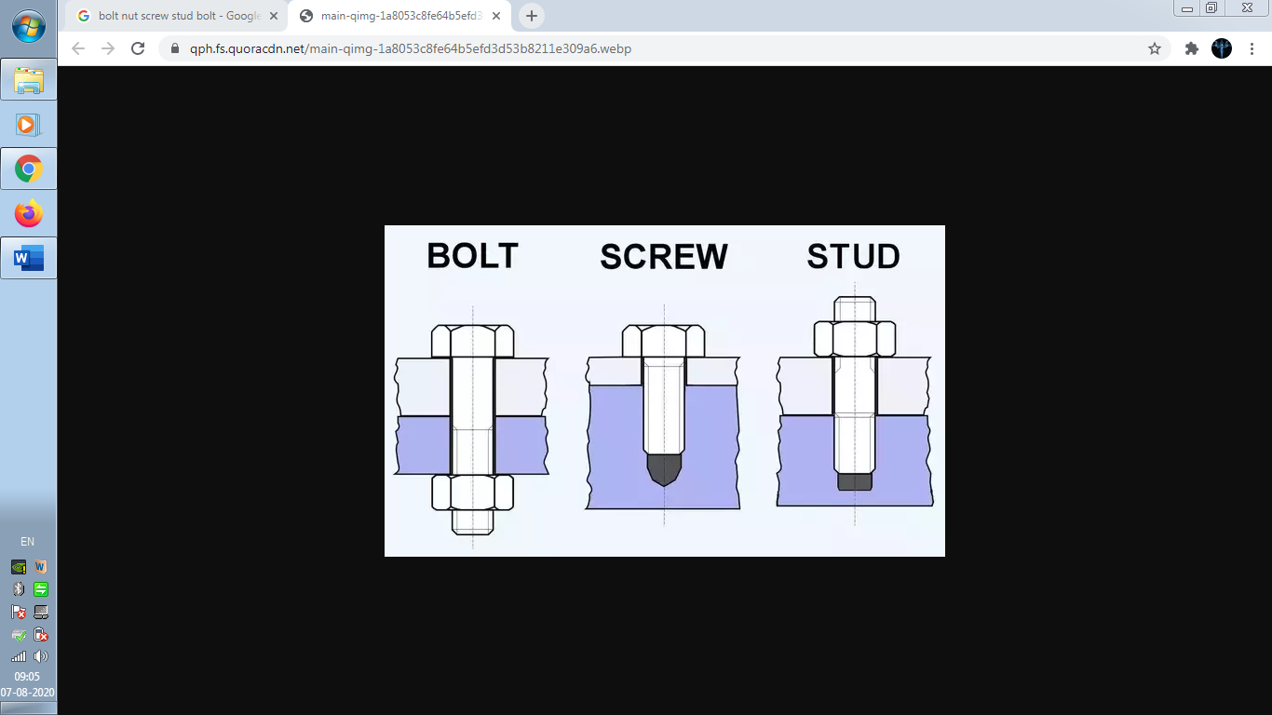 |  | 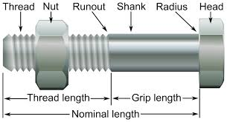
We Will consider Vee thread ISO-Metric Threads throughout study.  Notation: Md Eg. M20, M = Metric, d = d mm Nominal Diameter  d_{c} = Minor/ Root/ Core Diameter  d = Major/ Nominal Diameter | 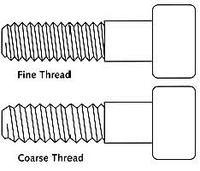 |  | 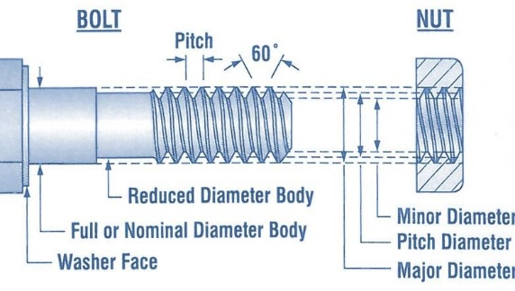

TENSILE STRESS IN BOLT:  Pre-Load: It’s the load comes due to clamping.  $$Normal Stress \left(σ_{t}\right):{F_{i}}/{A_{min}}, where A_{min}=\frac{π}{4}d_{c}^{2}$$  SHEAR STRESS IN THREAD:  Assuming there is no bending.  $$Shear Stress \left(τ\right)= {F_{i}}/{A_{Shear of teeth}}, where A_{Shear of teeth}=πd_{c}tn$$  CRUSHING STRESS IN THREAD:  $$Compressive Or Crushing Stress \left(σ_{c}\right):{F_{i}}/{A_{p}},$$  $$where A_{p}=n\frac{π}{4}(d^{2}-d_{c}^{2})$$ | n = number of terns of thread in contact,  $d_{c}$ = core diameter of the bolt,  $F_{i}$ = initial tension/ Pre-load,  t = thickness of teeth.
BOLT OF UNIFORM STRENGTH:
$$σ_{thread}=σ_{shank}={F_{i}}/{A_{min}}={F_{i}}/{A_{shank}}=constant$$  $$∴A_{min}=A_{shank}$$ | Possibility-I:  $$d_{c}=d_{shank}$$ | Possibility-II: Drilling hole in bolt  $$d_{h}=\sqrt{d_{shank}^{2}-d_{c}^{2}}$$
TENSILE STRESS DUE TO EXTERNAL LOAD: Assuming No Pre-load.
$$Normal Stress \left(σ_{t}^{e}\right):{F_{i}}/{A_{min}}, where A_{min}=\frac{π}{4}d_{c}^{2}$$
SHEAR STRESS DUE TO EXTERNAL LOAD: Assuming No Pre-load.
Shank undergoes shearing:  $$Shear Stress \left(τ^{e}\right):{F_{i}}/{A_{shank}}, where A_{shank}=\frac{π}{4}d_{shank}^{2}$$ | Threaded region undergoes shearing:  $$Shear Stress \left(τ^{e}\right):{F_{i}}/{A_{min}}, where A_{min}=\frac{π}{4}d_{c}^{2}$$
STRESSES IN BOLT DUE TO PRE-LOAD & EXTERNAL LOAD: Assuming Pre-load Condition.
$$F_{e}= F_{cm}+F_{b}$$  $$∆_{m}=\frac{F_{cm}}{K_{cm}}, ∆_{b}=\frac{F_{b}}{K_{b}}$$  $$∆_{m}=∆_{b}$$  $$F_{b}=C F_{e}, F_{cm}=(1-C) F_{e}$$  $$C=\frac{K_{b}}{K_{b}+K_{cm}}$$  $$R_{b}=F_{i}+F_{b}$$  $$R_{cm}={-F}_{i}+F_{cm}$$  Lack Proof Condition: $R_{cm}≤0$  Limiting Condition: $F_{i}=F_{cm}$ | n = number of terns of thread in contact,  $d_{c}$ = core diameter of the bolt,  $F_{i}$ = initial tension/ Pre-load,  $F_{e}$ = External load acting on a single bolt system,  $F_{cm}$ = The load acting on connecting member due to external load,  $F_{b}$ = The load acting on the bolt due to external load,  $∆_{m}$ = deformation of connecting members due to external load,  $∆_{b}$ = deformation of the bolt due to external load,  C = combined Stiffness factor,  $R_{b}$ = Resultant load on bolt,  $R_{cm}$ = Resultant load acting on the connecting members.
WELDED JOINTS:
Welding: It’s the process of joining two or more members with the application of heat, with or without application of pressure, and with or without filler material.  The Joint obtained by welding is called welded joint.  Neglecting Reinforcement:  t = thickness of plate or throat thickness  h = weld size or height of weld or leg size  - Butt Weld: Groove Weld: h = t  - Lap Weld: Fillet Weld: h > t | 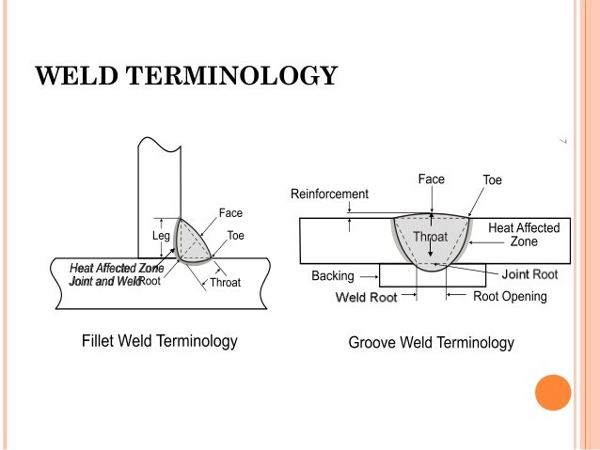
GROOVE WELD:
$$σ_{max}=\frac{F}{A_{min}}=\frac{F}{lt }$$  Butt joint Strength of groove $F_{b}=σ_{yt}lt=σ_{yt}lh$ | l = length of plate to be welded,  here, h = t
FILLET WELD:
Parallel Fillet Weld: If the length of weld is in the direction of load, then the fillet weld is said to be parallel fillet weld.  Assuming leg size is same in both directions.  $$Shear Stress \left(τ\right)=\frac{F}{t_{θ}l}$$  $$Where, t_{θ}= \frac{h}{\sin{θ}+\cos{θ}}$$  For maximum shear stress $θ=45°$,  $$τ_{max}=\frac{F}{lt }, where t=\frac{h}{\sqrt{2}}$$ | Transverse Fillet Weld: If the length of weld is in the perpendicular direction to load, then the fillet weld is said to be Transverse fillet weld.  At the θ angle plane Normal force ($F_{n}$) and Shear force ($F_{s}$) acts.  $$F=\frac{F_{n}}{\sin{(180-θ)}}=\frac{F_{s}}{\sin{(90+θ)}}$$  $$Shear Stress \left(τ_{θ}\right)=\frac{F_{s}}{t_{θ}l} and Normal Stress\left(σ_{θ}\right)= \frac{F_{n}}{t_{θ}l}$$  At maximum shear stress $θ=22.5°$,  $$τ_{max}=\frac{F}{lt}, where t=0.828h$$
$$At Failure: F_{p}^{l}=τ_{yt}lt, where t=h/{\sqrt{2}}$$ | $$At Failure: F_{t}^{l}=τ_{yt}lt, where t=0.828h$$
Strength of Fillet Weld $F_{s}=min \left\{F_{t}^{l},F_{p}^{l}\right\}=F_{p}^{l}$
$$F_{s}^{l}=1.17F_{p}^{l}$$
Circumferential Fillet Weld: On axial load Failure is as per Parallel Fillet weld but $l=πd$.
AXIALLY LOADED UNSYMMETRICAL FILLET WELD:
$$\sum{M_{CG}=0}⇔\left(tl_{1}\right)y_{1}=\left(tl_{2}\right)y_{2}⇔\frac{l_{1}}{l_{2}}=\frac{y_{2}}{y_{1}}$$  $$\frac{l}{l_{2}}=\frac{{y_{1}+y}_{2}}{y_{1}} and \frac{l}{l_{1}}=\frac{{y_{1}+y}_{2}}{y_{2}}$$ | Total Length of weld $l=l_{1}+l_{2}$  $$y={y_{1}+y}_{2}$$  Total Axial Force $F=F_{1}+F_{2}$  $$F_{1}=F\frac{l_{1}}{l} and F_{2}=F\frac{l_{2}}{l}$$
ECCENTRIC LOADING:
If the load is not passing the centre of gravity of element system then the loading is said to be eccentric loading.
EFFECTS OF ECCENTRIC LOADING
Primary Effects (Direct Load) |  | Secondary Effects (Moment or Torsion)
In the direction of axis of element | In the direction parallel to the cross section of element | In the direction of axis of element | In the direction parallel to the cross section of element
Normal Load | Shear Load | Normal Load | Shear Load

Moment Balance:  $$M= \sum_{i}{F_{si}r_{i}} and F_{s}∝r$$  $$∴F_{s}=C r_{max}, where C= \frac{M}{\sum_{i}{r_{i}^{2}}}$$ | $r$ = distance from the element of axis of rotation  $F_{s}$ = Shear Load  $r_{i}$ = distance from the i^{th} element of axis of rotation  $F_{si}$ = Shear Load on i^{th} element

FOR RIVETED AND BOLTED JOINTS:
CASE-I:
$$primary load F_{p}= F/n$$  $$Secondary load F_{s}=C r_{max}=\frac{Fe}{\sum_{i}{r_{i}^{2}}}r$$  $$Resultant Load R=\sqrt{F_{p}^{2}+F_{s}^{2}+2F_{p}F_{s}\cos{θ}}$$ | Effect of primary loading = Shear Stress  Effect of Secondary loading = Shear Stress  $θ$ = Included Angle between primary and secondary load  e = distance between load and axis of rotation of system.  $r_{i}$ = distance between centre of i^{th} element to CG of element
Finding Critical Element:
- The Element should be far away from the axis of rotation of system (CG). (“r” to be maximum)
- When “r” remains the same, the element with less “$θ$” is more critical.
$$Maximum shear stress τ_{max}=\frac{R_{max}}{A_{min}}=\frac{τ_{yt}}{FOS}$$ | $$R_{max}=resultant load on the critical element.$$  $$A_{min}=mimimum area of rivet shank or bolt core$$
CASE-II:
$$primary load F_{p}= \frac{F}{n}$$  $$Secondary load F_{s}=C l_{max}=\frac{Fe}{\sum_{i}{l_{i}^{2}}}l$$  From the theories of Failures (MSST):  $$σ_{1}-σ_{2}={σ_{yt}}/{FOS}$$  $$\frac{1}{A}\sqrt{4F_{p}^{2}+F_{s}^{2}}= \frac{σ_{yt}}{FOS}$$ | Effect of primary loading = Shear Stress  Effect of Secondary loading = Normal Stress  e = distance between Applied load and axis of rotation of system.  $A_{min}$ = minimum area of rivet shank or bolt core  $l_{i}$ = distances from the axis of rotation to centre of i^{th} element  $σ_{x}={F_{s}}/{A_{min}}$ and $τ_{xy}={F_{p}}/{A_{min}}$
CASE-III:
$$primary load F_{p}= \frac{F}{n}$$  $$Secondary load F_{s}=C l_{max}=\frac{Fe}{\sum_{i}{l_{i}^{2}}}l$$  $$Resultant Load R=F_{p}+F_{s}$$  $$Maximum Normal Stress σ_{max}=\frac{R_{max}}{A_{min}} =\frac{σ_{yt}}{FOS}$$ | Effect of primary loading = Normal Stress  Effect of Secondary loading = Normal Stress  $R_{max}$ = resultant load on the critical element.  e = distance between Applied load and axis of rotation of system.  $A_{min}$ = minimum area of rivet shank or bolt core  $l_{i}$ = distances from the axis of rotation to centre of i^{th} element  $$R_{max}= \frac{F}{n}+Cl_{max}$$

FOR WELDED JOINTS:
CASE-I:
$Total Area A=lt and Total Welding length l=\sum_{i}{l_{i}}$  $$primary load τ_{p}=F/A$$  $$Secondary load τ_{s}= \left(M/J\right) r$$  $Resultant Load R=\sqrt{τ_{p}^{2}+τ_{s}^{2}+2τ_{p}τ_{s}\cos{θ}}$ | $Total Plar Moment of inetia J= \sum_{i}{J_{i}}=\sum_{i}{A_{i}\left[\frac{l_{i}^{2}}{12}+h_{i}^{2}\right]}$  $$Maximum shear stress τ_{max}=\frac{R_{max}}{A_{min}}=\frac{τ_{yt}}{FOS}$$
CASE-II:
$Total Area A=lt and Total Welding length l=2b$  $$primary load τ_{p}= F/A,$$  $$Secondary load σ_{s}= \left(M/I\right) y, where M=Fe$$ | From the theories of Failures (MSST):  $$\sqrt{4τ_{p}^{2}+σ_{s}^{2}}= {σ_{yt}}/{FOS}$$

